Multiple-choice section

|  |  |  |  |  |  |  |
| --- | --- | --- | --- | --- | --- | --- |
| Question | 1 | 2 | 3 | 4 | 5 | 6 |
| Answer | B | D | A | D | C | B |

Question 1 [8.3]

B

P(x) = -x3 + 3x2 + 7x – 1

P(-2) = -(-2)3 + 3(-2)2 + 7(-2) – 1

= 5

Question 2 [8.2]

D

To transform y = x2 to y = -x2, reflect in the x-axis.

To transform y = -x2 to y = -7x2, dilate by a factor of 7 in the y direction.

To transform y = -7x2 to y = 3 – 7x2, translate 3 units up.

Question 3 [8.3]

A

P(x) = 8 – 3x2 + 5x4

Degree = 4; Leading coefficient = 5; Constant = +8

Question 4 [8.3]

D

P(x) = 4x3 – 2x2 + 3x – 2

P(0.5) = 4 ×  – 2 ×  + 3 ×  – 2

= -0.5

Question 5 [8.5]

C

For x = 0: y = 5x3 – 2x − 6 + 11x2 = -6

Question 6 [8.2]

B

y = x3

Dilating by a factor of 5: y = 5x3

Translating the graph 3 units to the right: y = 5(x – 3)3

Translating the graph 4 units down: y = 5(x – 3)3 – 4

Multiple-choice total marks: 6

Short answer section

Question 7 3 marks [8.2, 8.3]

(a) A quotient is the result of one polynomial divided by another. If the divisor is a factor of the dividend, there will be no remainder.

(b) The equation y = (2x – 3)2 is a quadratic equation.

Question 8 3 marks [8.2]

A graph can be transformed by a reflection, a dilation or a translation.  
A reflection in the x-axis turns the graph upside down.  
A dilation of ‘a’ makes the graph of the polynomial either narrower (a ≥ 1) or wider (0 < a < 1).  
A translation shifts the graph left or right, up or down.  
The shape of the graph remains the same for a translation and a reflection.

Question 9 8 marks [8.2]

(a) (i) (0, -2) (ii) 

(b)

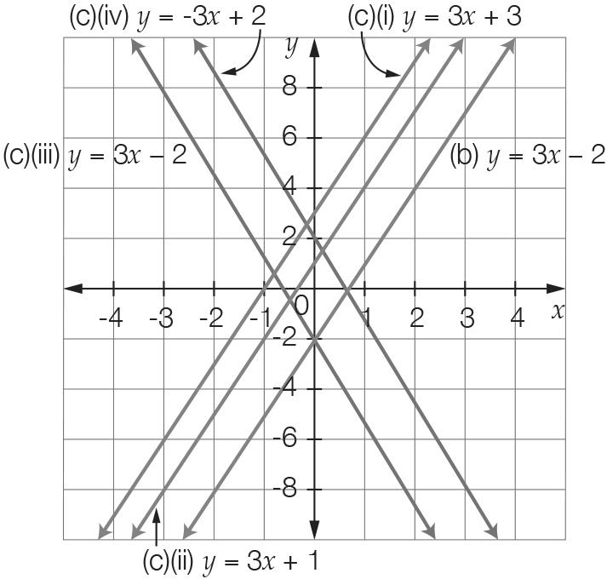

(c) (i) y =3x + 3 (ii) y = 3x + 1 (iii) y = -3x – 2 (iv) y = -3x + 2

Question 10 8 marks [8.2]

(a) (i) (0, 8) (ii) (3, -1) (iii) (2, 0) and (4, 0)

(b)

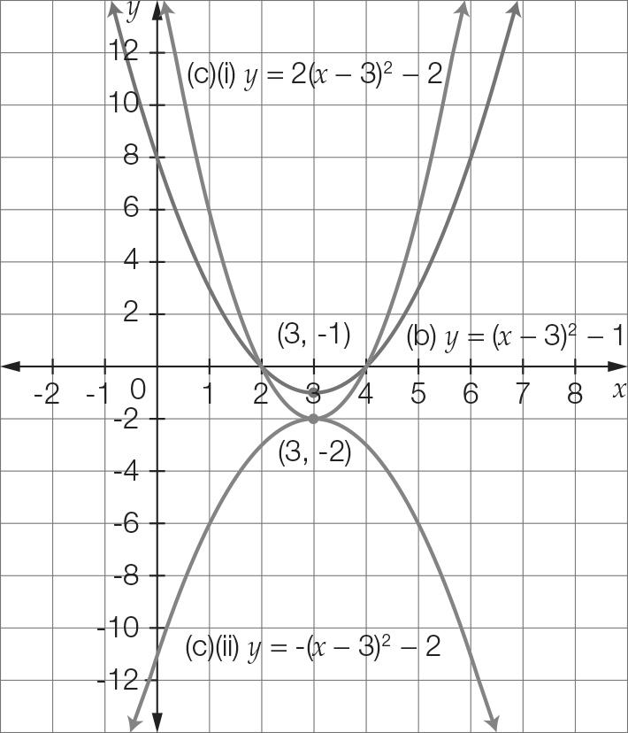

(c) (i) y = 2(x – 3)2 – 2 (ii) y = -(x – 3)2 – 1

Question 11 3 marks [8.1]

(a)

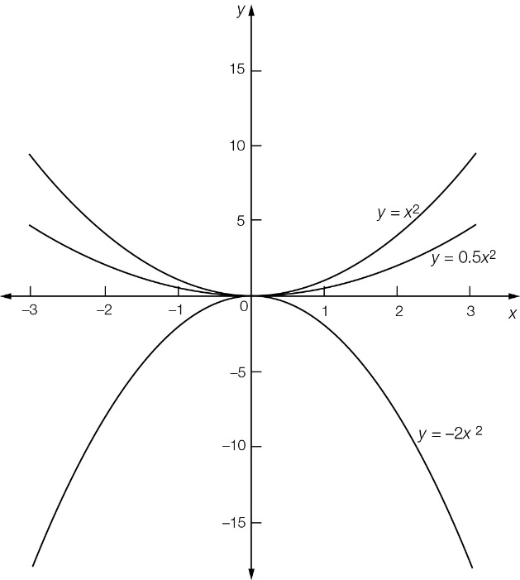

(b) The shape becomes narrower as the magnitude of the coefficient increases. A negative coefficient reflects the graph in the x-axis.

Question 12 3 marks [8.2]

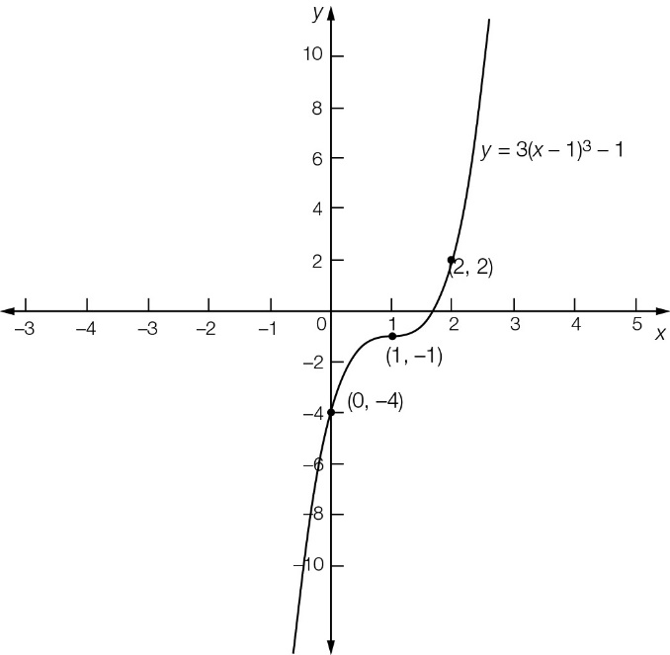

Point of inflection = (1, -1); y-intercept = (0, -4) ; Required point = (2, 2)

Question 13 4 marks [8.2]

(a) y = x2  
Translate 4 to the left: y = (x + 4)2   
Translate 4 to the left and 3 down: y = (x + 4)2 – 3

(b) y = x2  
Reflect in the x-axis: y = -x2  
Reflect in the x-axis, dilate by 2 in the x-direction: y = -2x2  
Reflect in the x-axis, dilate by 2 in the y-direction, translate 1 to the right: y = -2(x – 1)2  
Reflect in the x-axis, dilate by 2 in the y-direction, translate 1 to the right, translate 5 up  
y = -2(x − 1)2 + 5

Question 14 5 marks [8.5]

For x = 0, y = c  
c = 12

For x = 1, a + b + 12 = 0 [1]

For x = -4, 16a – 4b + 12 = 0 [2]

Add equations 4 × [1] and [2]

20a = -60

a = -3

By substitution in equation [1]

-3 + b + 12 = 0

b = -9

a = -3, b = -9, c = 12

Question 15 2 marks [8.4]

P(x) = 4x2 + x – 3

P() = 4 ×  +  – 3

= ** +  – 3

= 0

Given that P() = 0, then 4x – 3 is a factor.

Question 16 2 marks [8.3]

Answers will vary, but the polynomial must have four terms, the highest power of x must be 5 and the coefficient of this term must be a negative.

e.g. -2x5 + 3x2 + 5x – 2

Question 17 4 marks [8.5]

Point of inflection at (-2, -3) and passes through the point (-3, -5).

y = m(x – h)3 + k Turning point at (-2, -3):

h = -2, k = -3

y = m(x + 2)3 − 3

Substitute (-3, -5):

-5 = m(-1) – 3

m = 2

y = 2(x + 2)3 – 3

= 2(x3 + 6x2 + 12x + 8) – 3

= 2x3 + 12x2 + 24x + 13

a = 2, b = 12, c = 24 and d = 13

Question 18 5 marks [8.4]

P(1) = 2 + 3 – 2 – 3 = 0

so x – 1 is a factor.



P(x) = (x – 1)(2x2 + 5x + 3) = (x – 1)(x + 1)(2x + 3)

Question 19 4 marks [8.3]

2a(x) × b(x) − c(x)

= 2(2x – 3)(5 – 2x2) − (3x3 + 5x – 4)

= 20x − 8x3 – 30 + 12x2 − 3x3 − 5x + 4

= -11x3 + 12x2 + 15x – 26

Question 20 5 marks [8.3]

(a)

  
Q(x) = 2x2 – x − 1, remainder 5

(b) P(x) = 4x3 – 3x + 4  
P(x) = (2x + 1)(2x2 – x – 1) + 5

Question 21 2 marks [8.3]

Answers will vary, but polynomial must be a cubic and P(0.5) must be zero.

Question 22 2 marks [8.3]

P() = 0



Short answer total marks: 63

Extended answer section

Question 23 5 marks [8.2]

(a) y = 4 – 0.25(x – 4)2 + 4  
= 8 – 0.25(x – 4)2

(b) 8 – 0.25(x – 4)2 = 0  
32 – (x – 4)2 = 0  
(+ (x – 4)) ( − (x – 4)) = 0  
x = 4 –   
x = 9.7 m (reject negative value for x)

(c) Maximum height at vertex (4, 8) is 8 m.

Question 24 6 marks [8.5]

(a) y = 0.02(x3 – 30x2 + 189x)   
y = 0.02x(x2 – 30x + 189)  
 = 0.02x(x − 9)(x − 21)

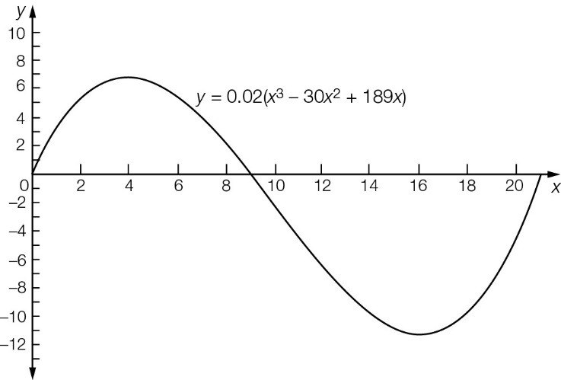

(b) x = 0, 9, 21 (where y = 0)

(c) Distance from one side to the other is 21 m.

Question 25 5 marks [8.5]

(a) Graph shown where d is on the y-axis and w is on the x-axis.

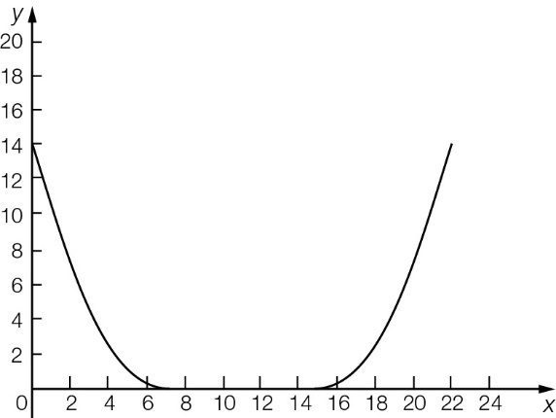

(b) 22 cm

(c) Depth of bowl (where w = 0)  
= (-7)2 = 14 cm

Extended answer total marks: 16

TOTAL test marks: 85